[E127] Boil temperature switch

Remove the heat insulations.

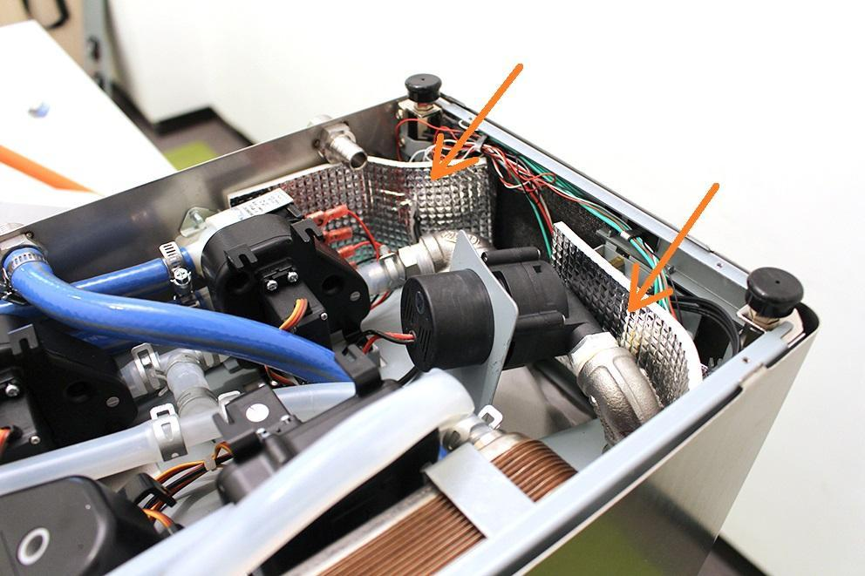

Unscrew the strain relief lock nut.

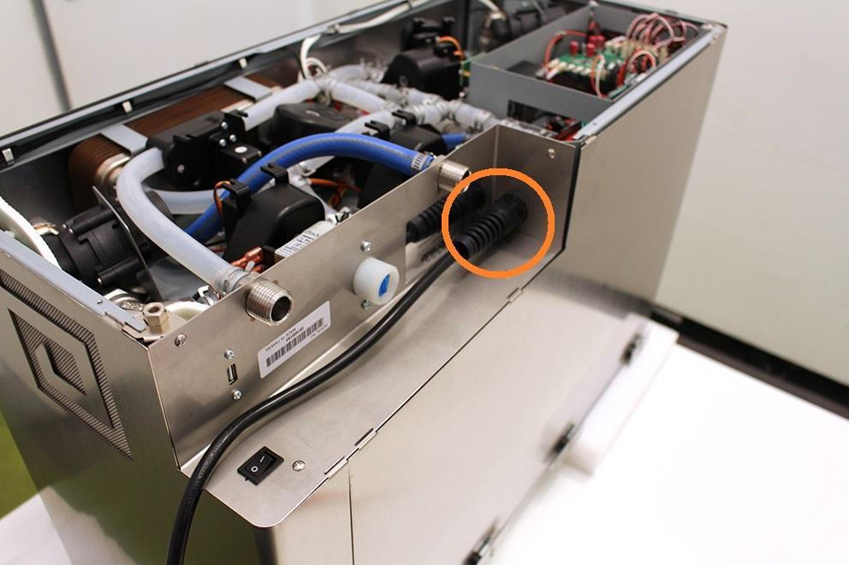

Remove the wort outlet hose clamp, pull off the wort outlet silicone tube and unscrew the indicated screws.

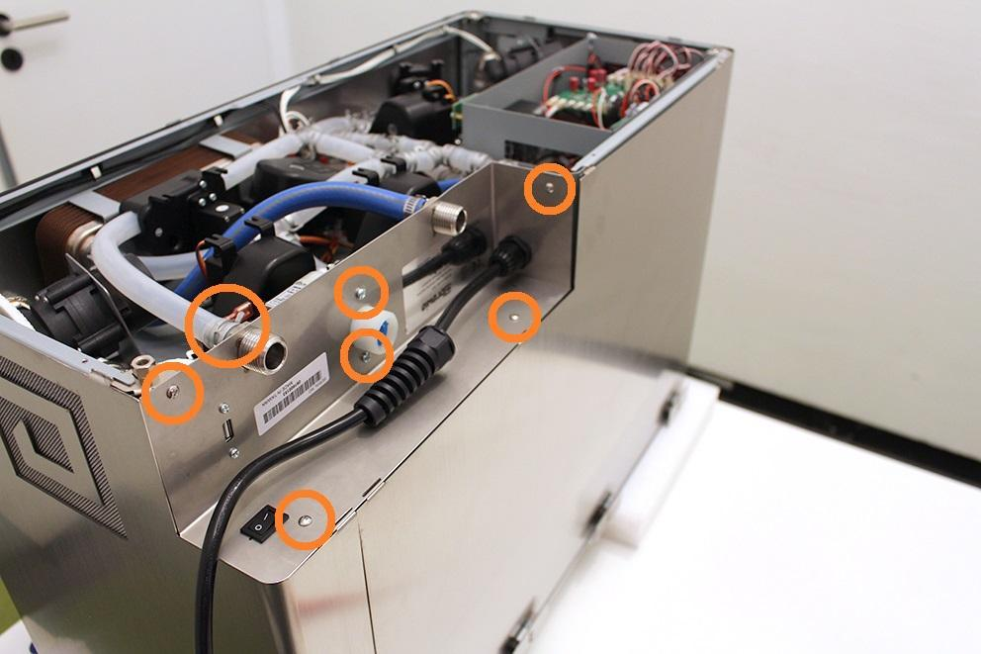

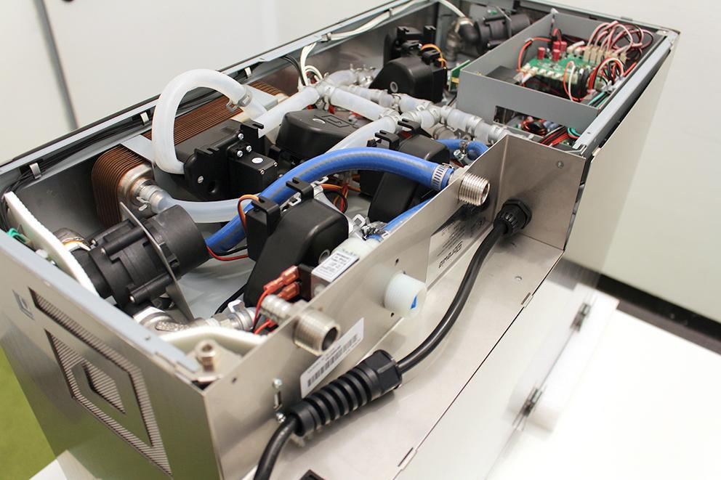

Remove the USB plug. Make sure that the washers don’t fall under the assembling plate. Use magnet for this step.

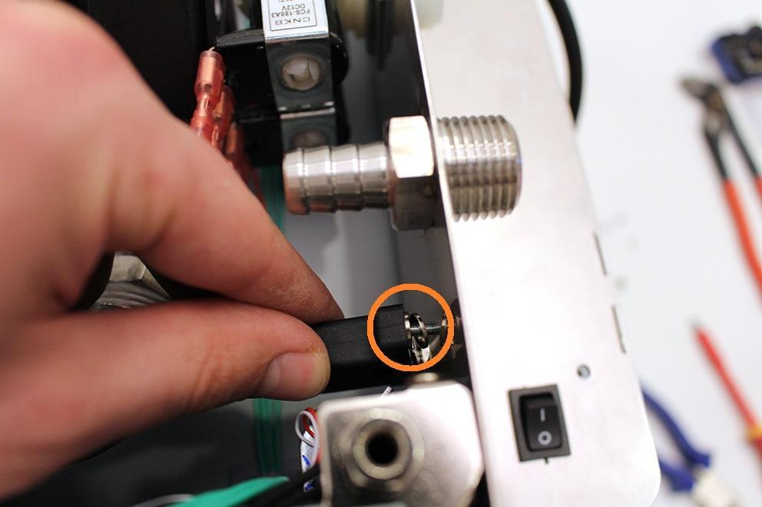

Loosen the indicated hose clamp and remove the high pressure hose from the fitting.

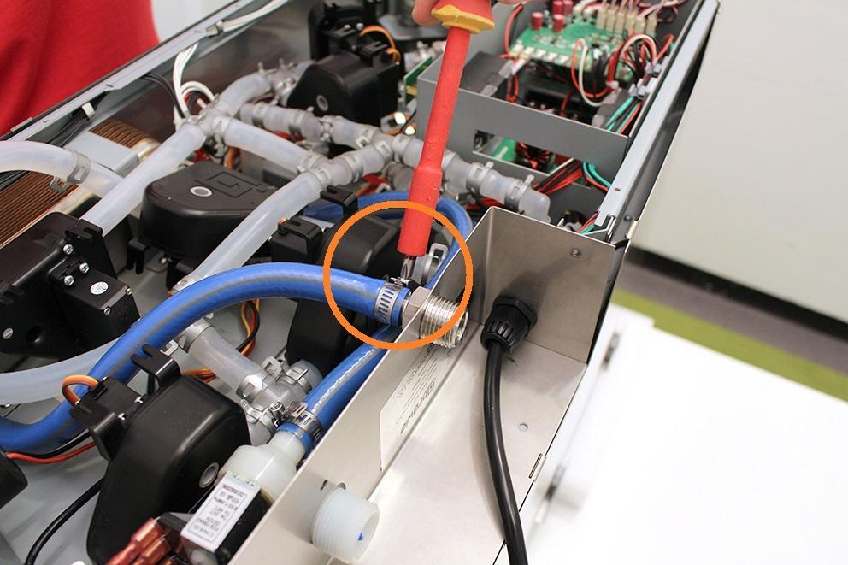

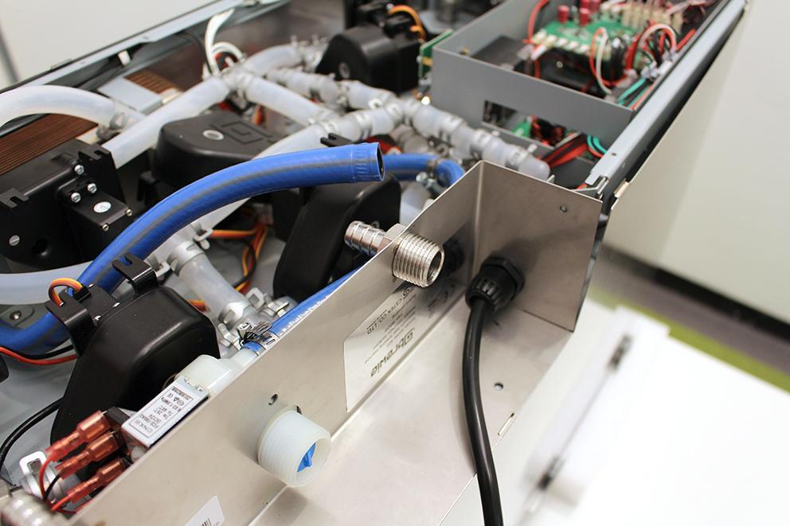

Lift the sheetmetal part carefully and disconnect the indicated plugs with a screwdriver.

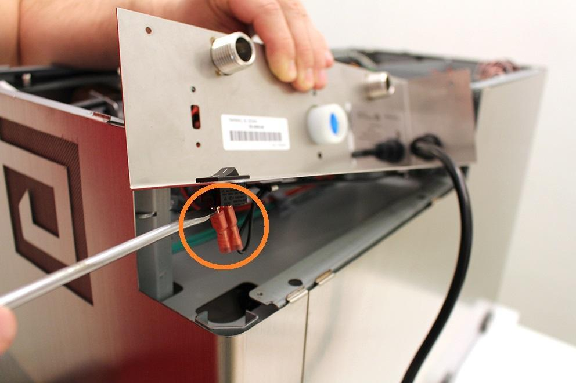

Remove the cables from the cable clips.

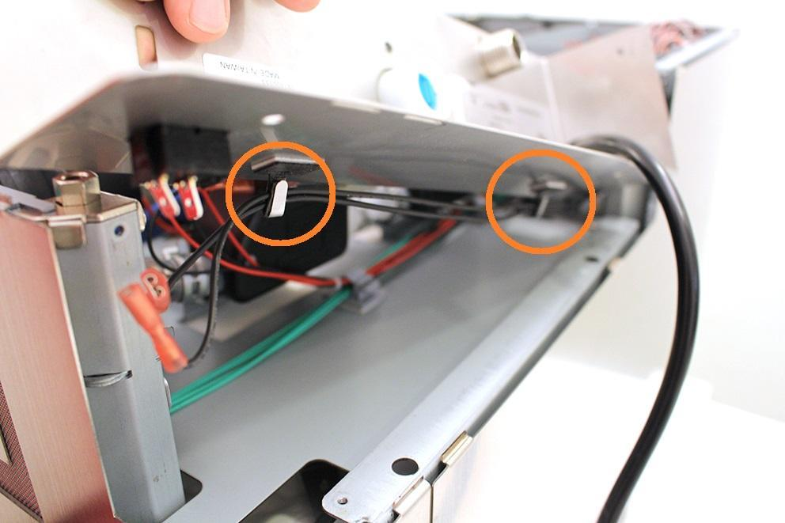

Pull off the high pressure valve from the sheetmetal. Pull off the sheetmetal on the power cable and put it in a safe place.

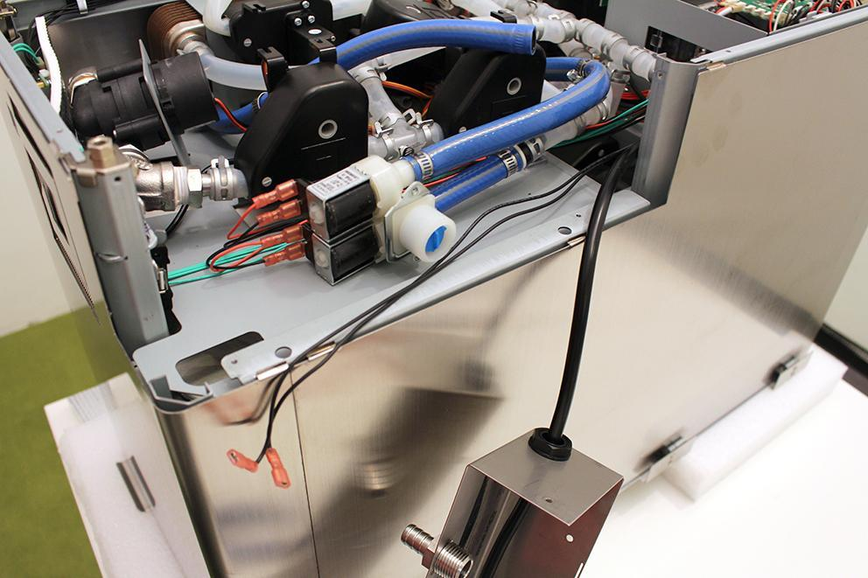

Remove the indicated heat insulation and remove the indicated cable tie.

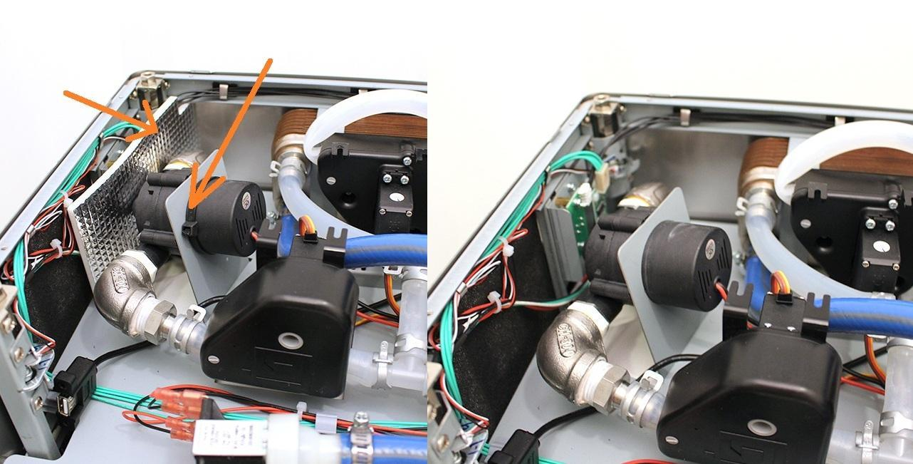

Pull off the pipe clamp from the encircled fitting. Pull off the silicone hose from the fitting.

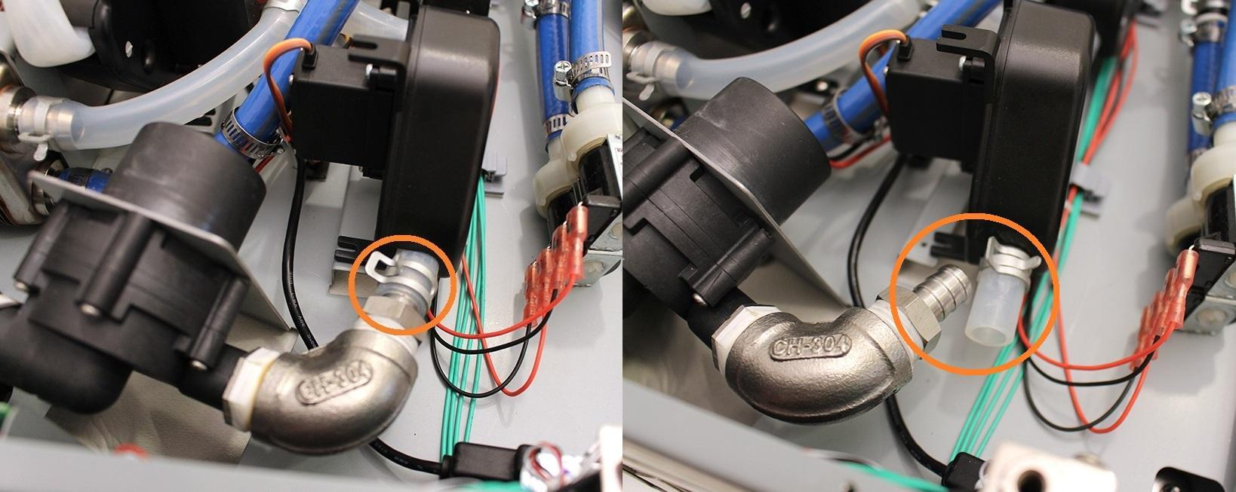

While you keep the indicated hose clamp tightly, you can pull off the pump from the silicone tube by rotating the pump around its axis.

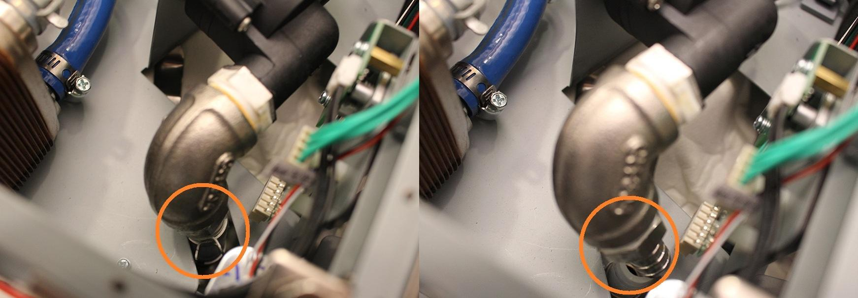

Bend the pump holder sheetmetal carefully in order to remove the pump easier.

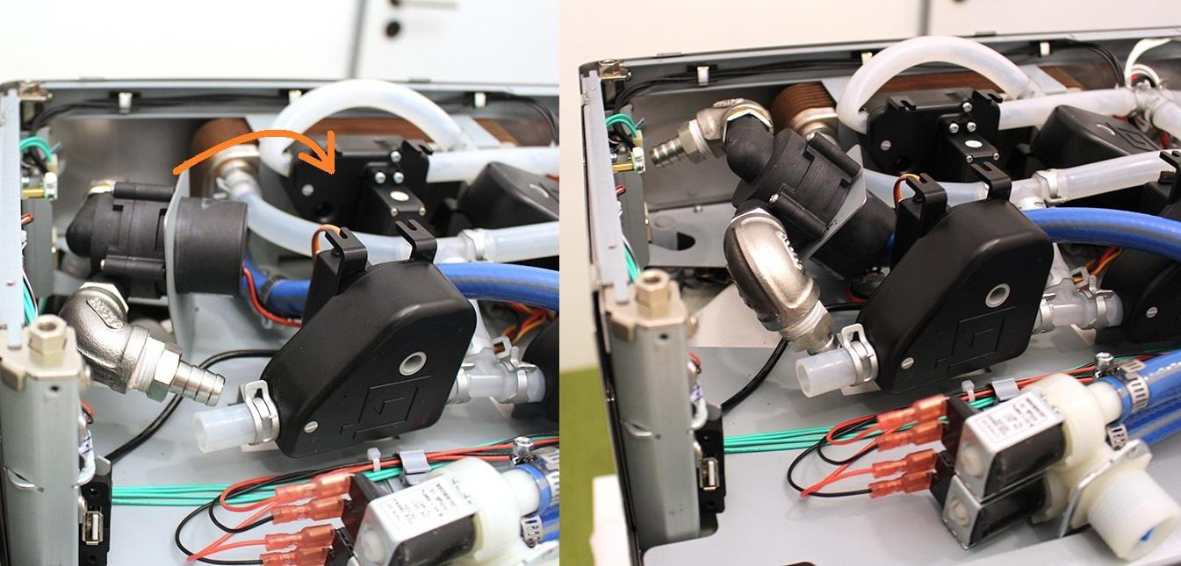

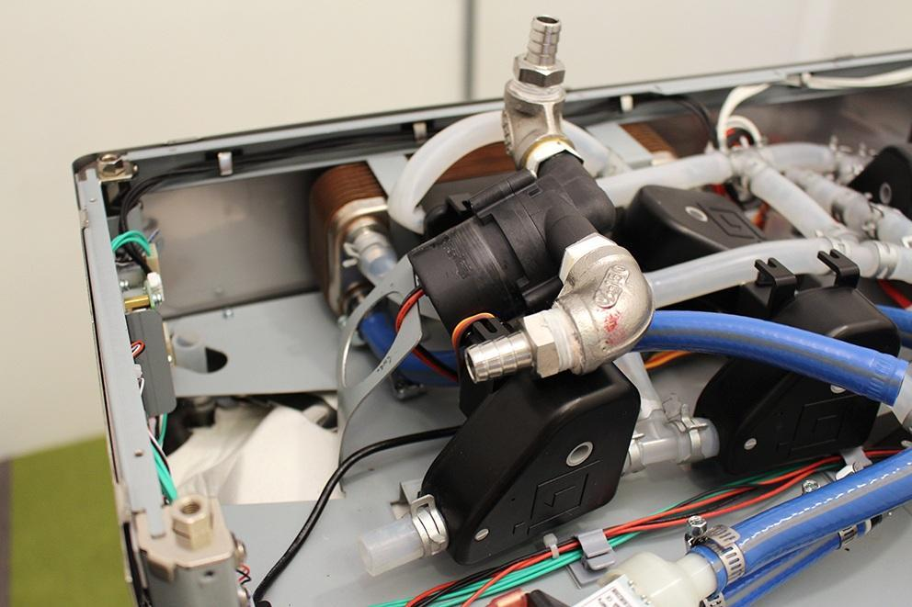

Remove the indexed valve (see at: “Remove the wort outlet valve”).

Remove the heat exchanger holder clamps.

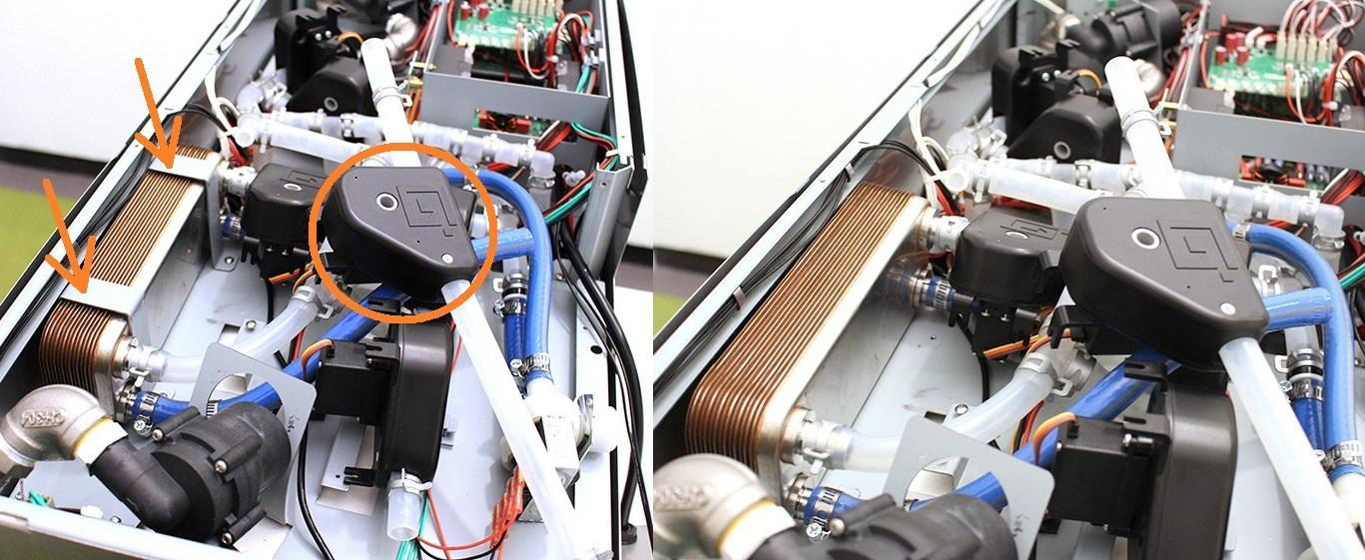

Unscrew the 4 indicated assembly plate screws.

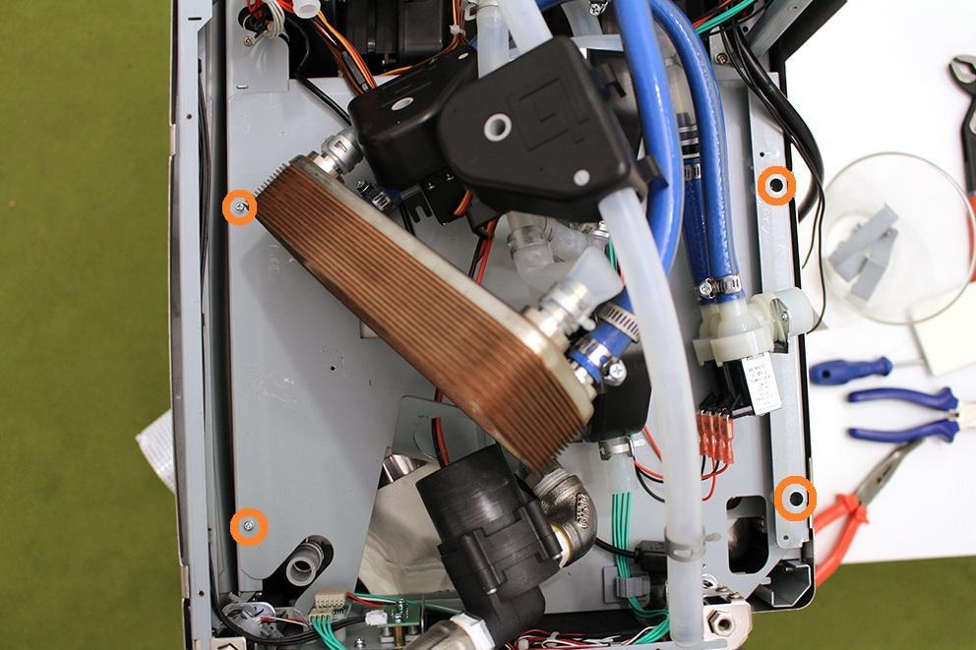

Disconnect the two indicated plugs, remove the cables from the indicated cable clips. Put the cables outside the machine in order to avoid the damage of the cables.

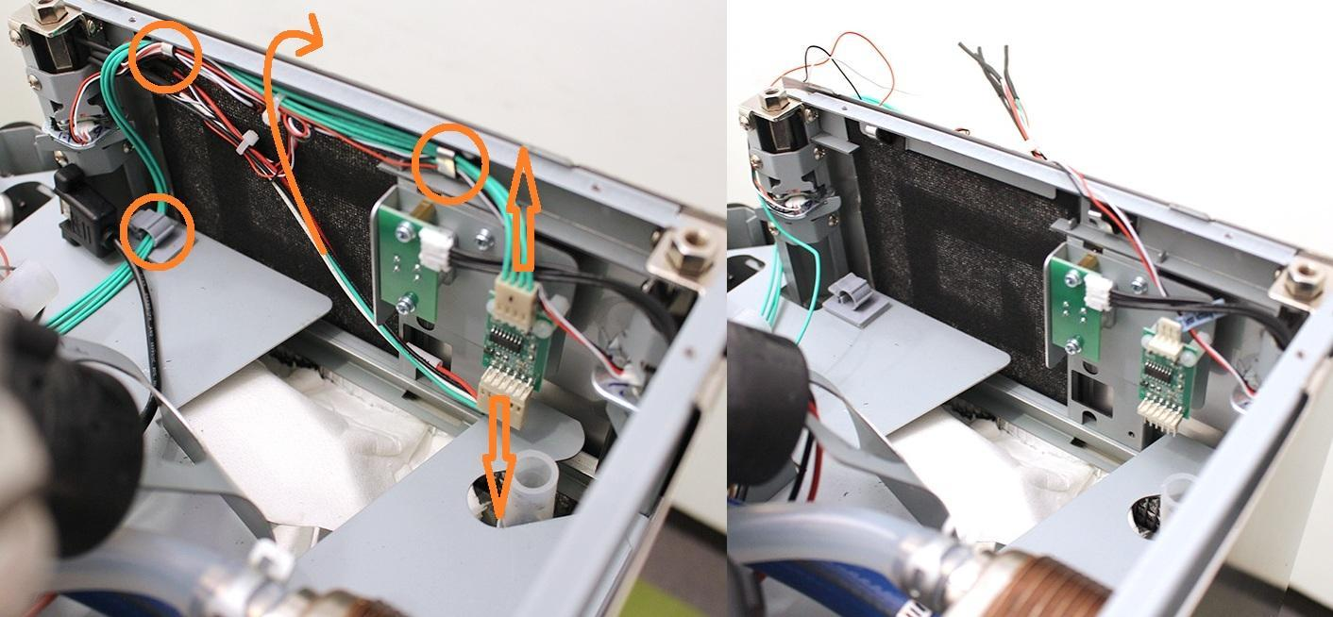

Remove the cables from the indicated cable clips.

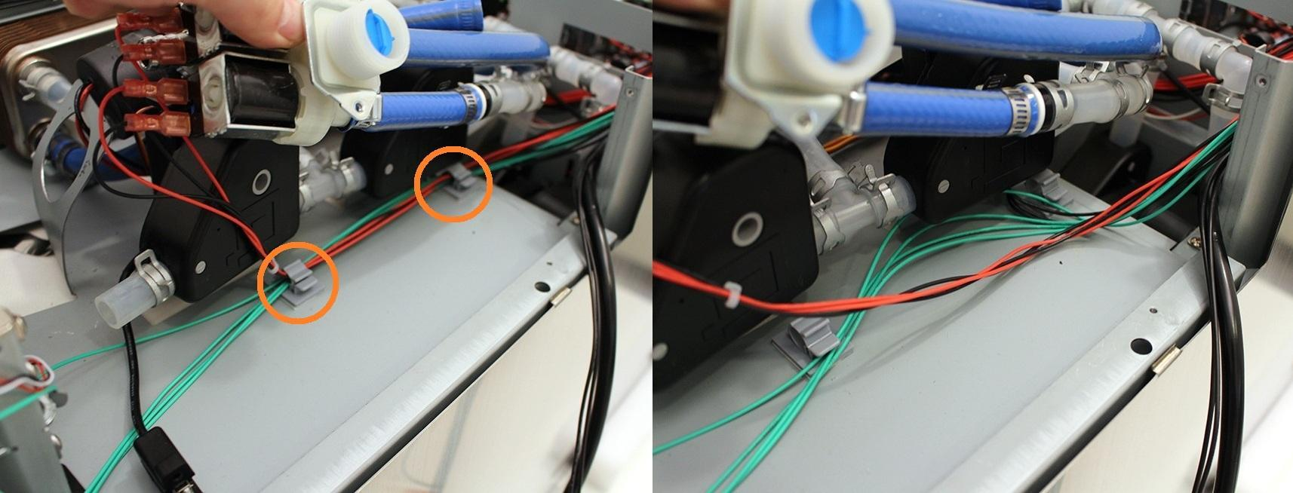

Remove the cables from the indicated cable clips. The right picture shows where to put the power and switch cords in order to avoid any damage to these cables.

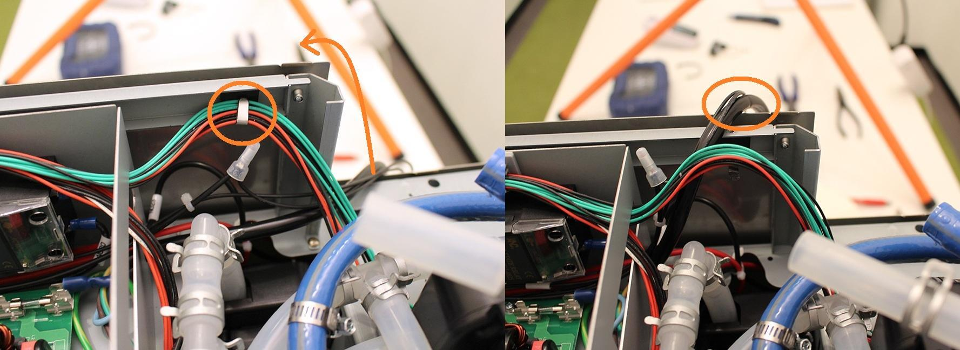

Remove the cable of the temperature sensor from the indicated cable clip. Avoid strain of this cable during further assembling.

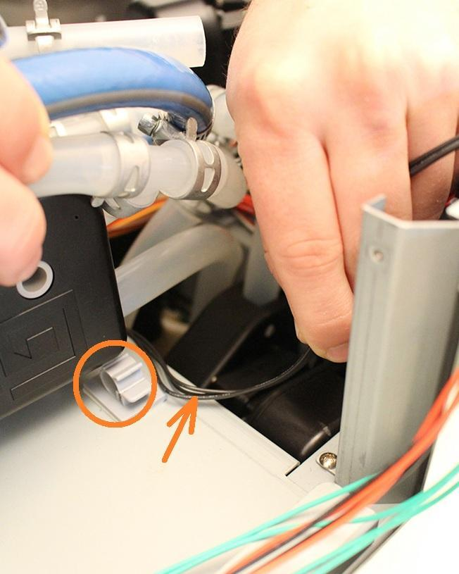

Disconnect the button plug, unscrew the indicated screws and remove the button unit.

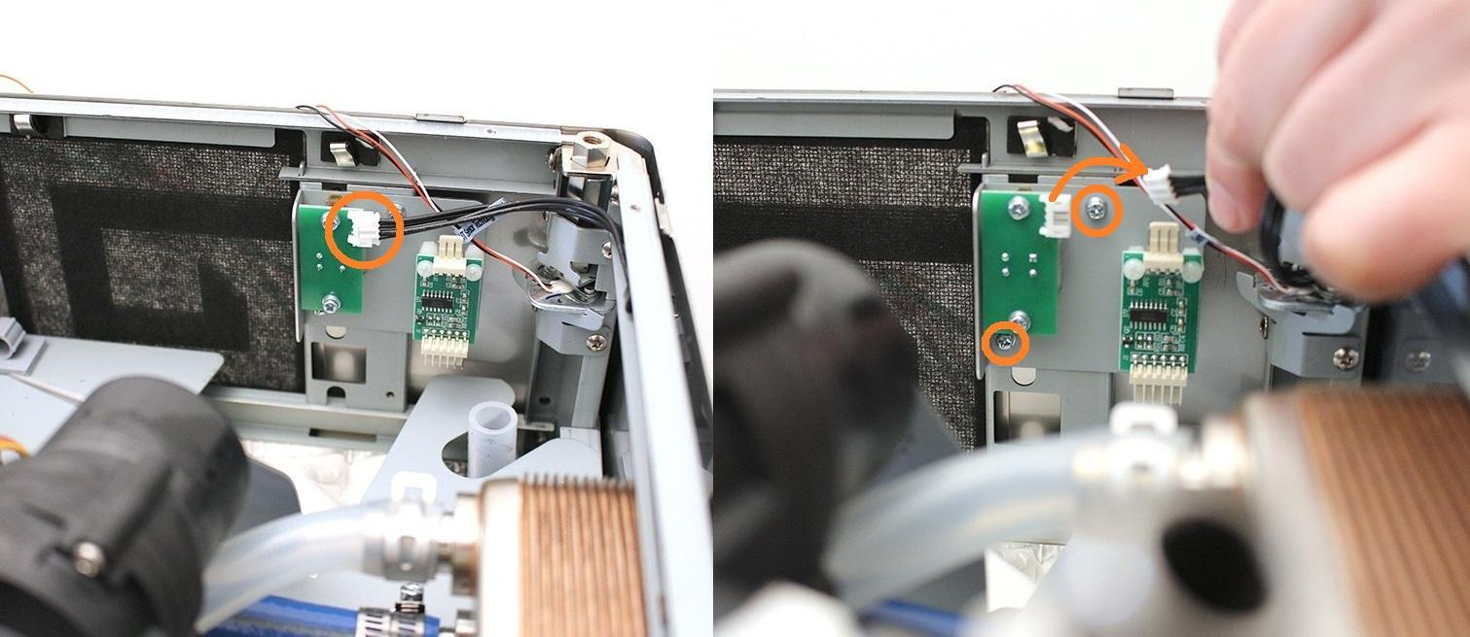

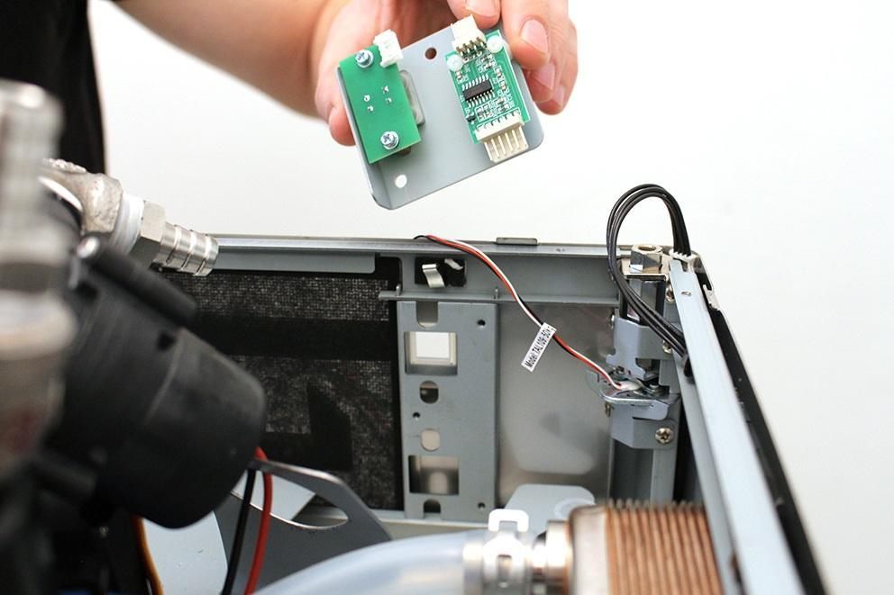

Loosen the screws of the two indicated valves, and remove them from their position.

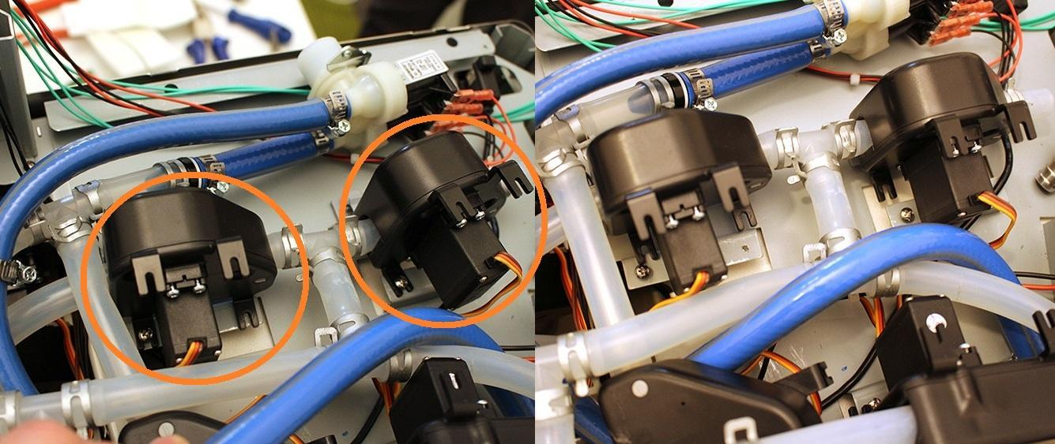

Lift the assembly plate carefully. Make sure not to damage the cables by the sheetmetal.

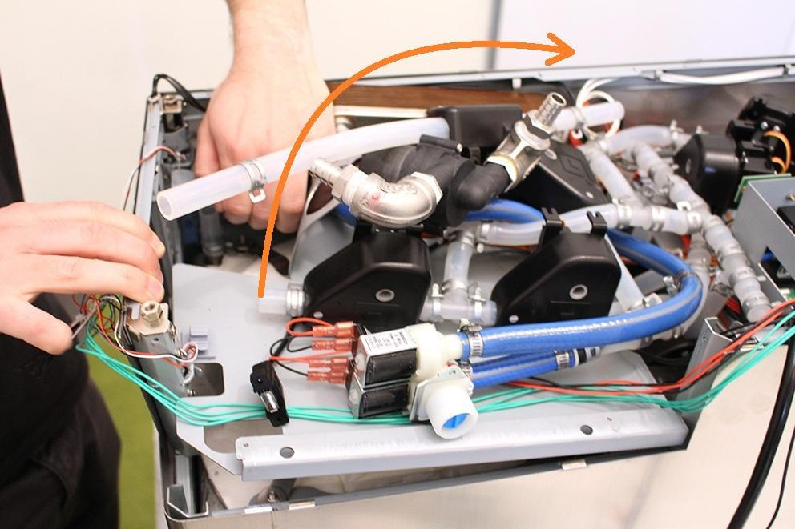

While lifting up the assembly plate, make sure not to damage the cables at the indicated areas.

We recommend to place the button plug as shown on the picture in order to avoid damage.

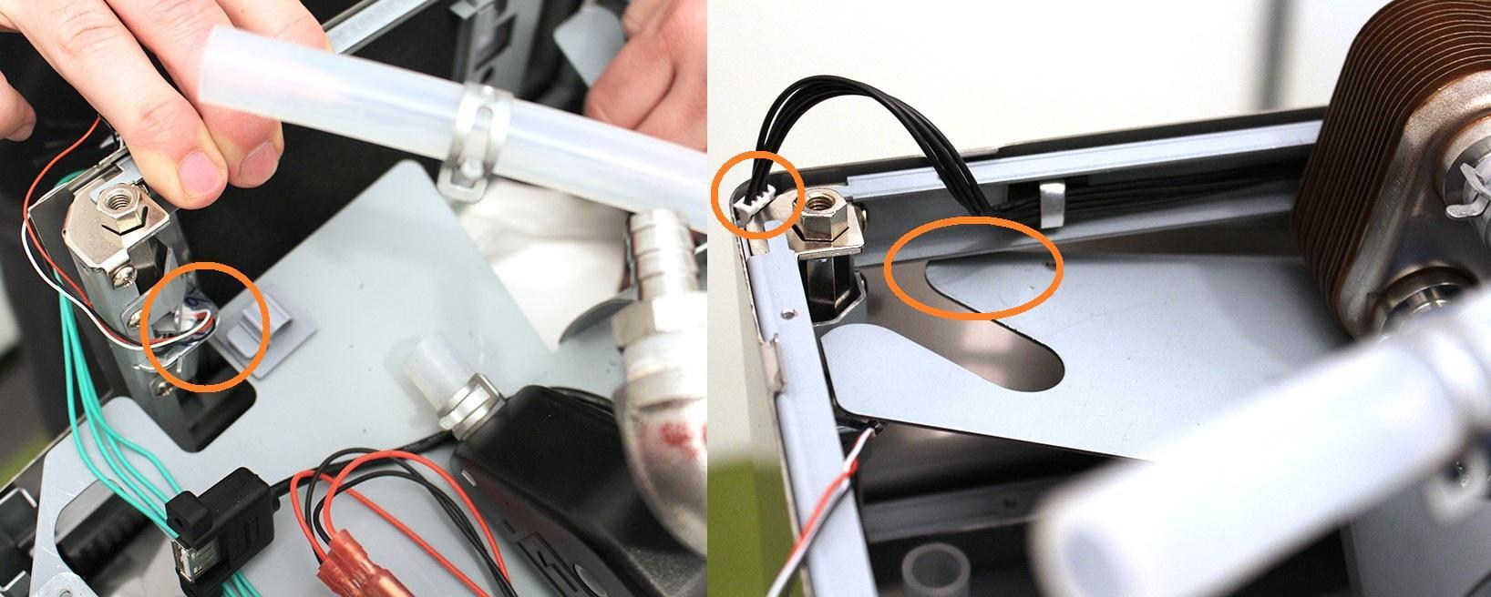

We recommend to fix the assembly plate with a soft object as it shown on the right picture.(It must be soft to avoid the scratches on the cover of the machine).

Rotate the 4 indicated heat plate clamps to free the heatplate.

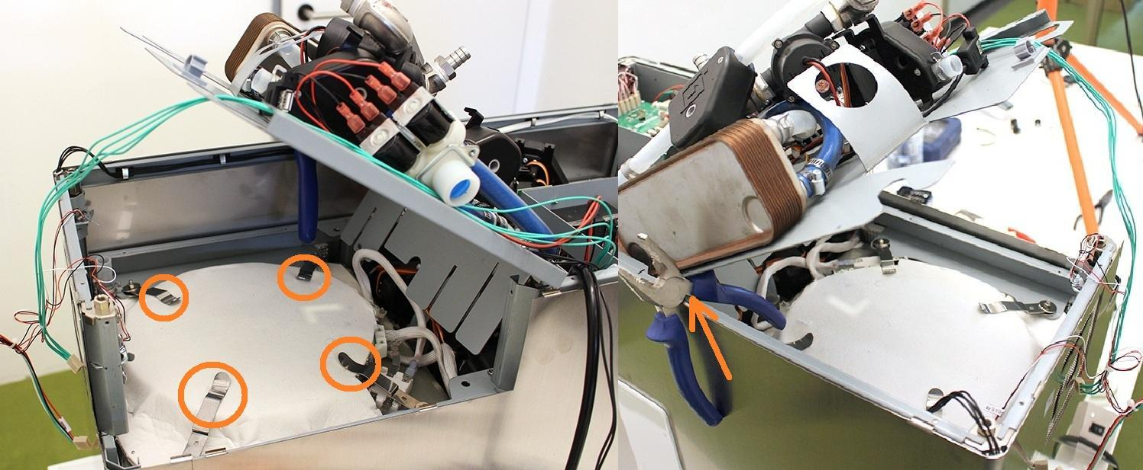

Remove the indicated heat plate cables.

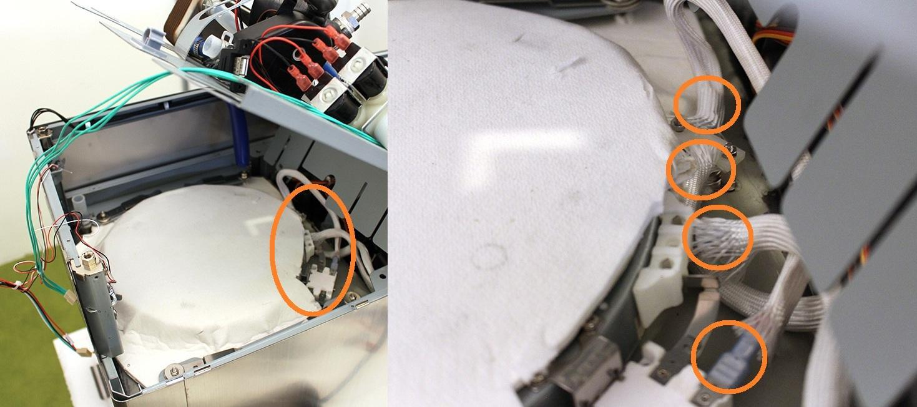

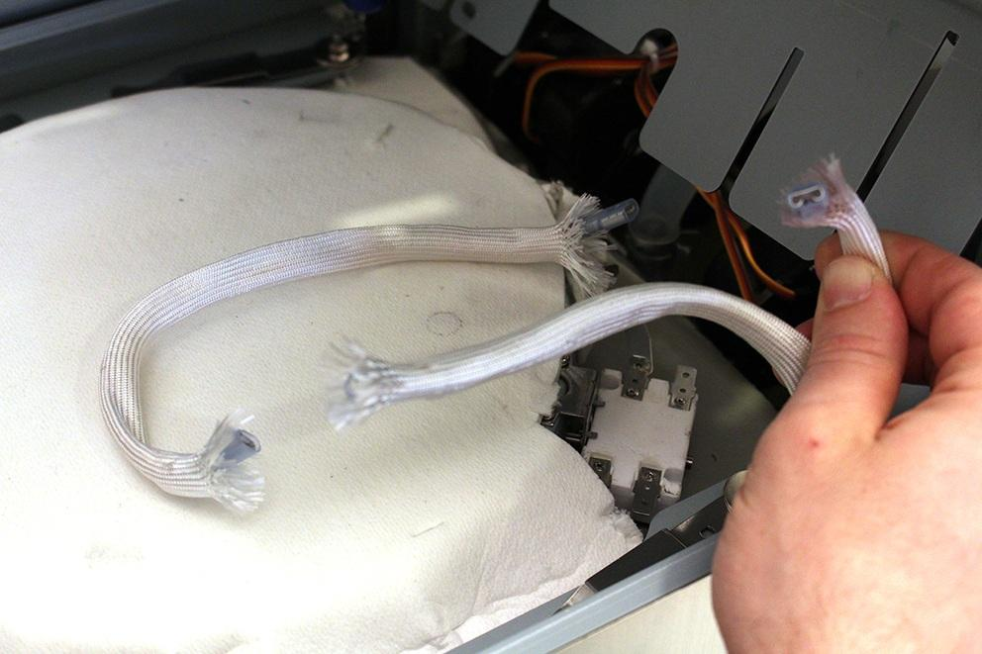

Remove one side of the heat insulation carefully.

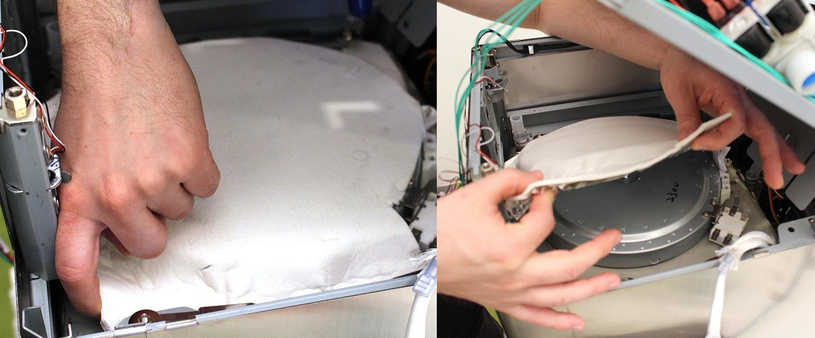

Now the heat plate can be removed.

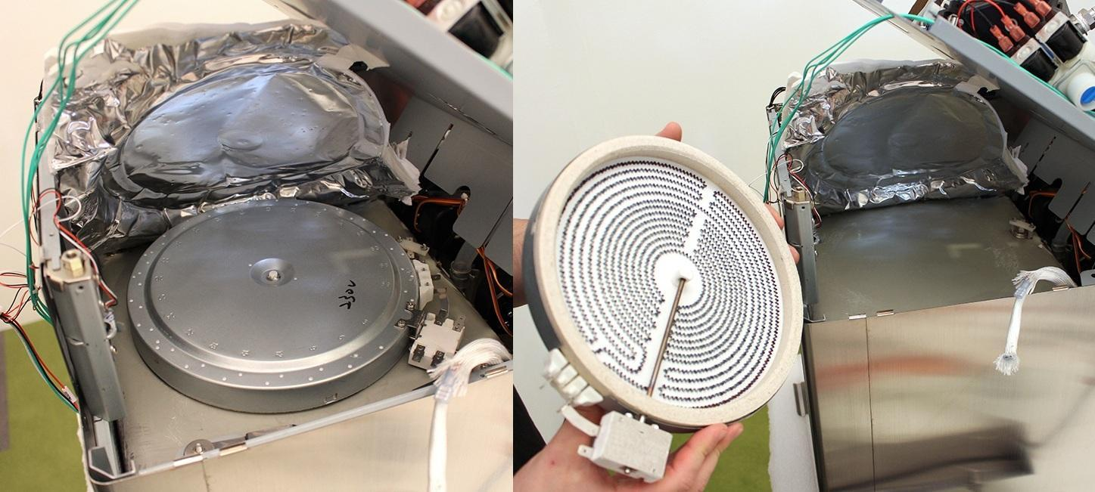

Remove the 4 locknuts.

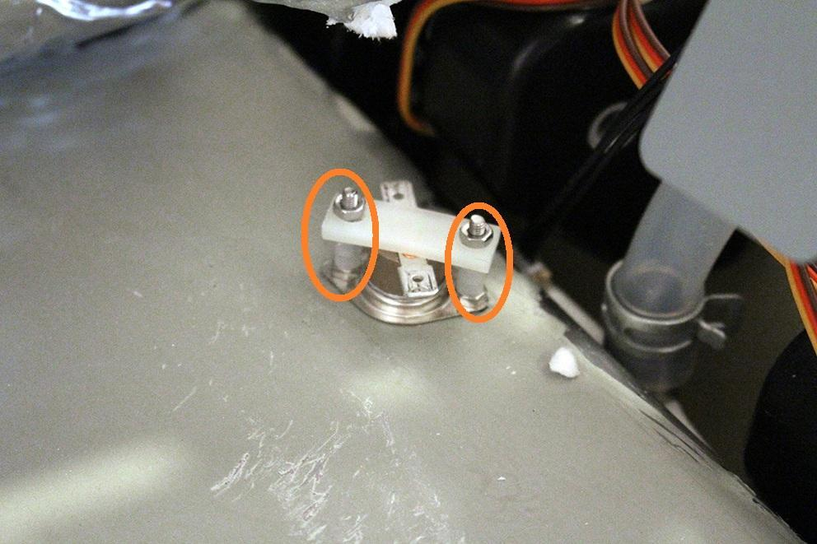

Now you can replace the part.

Reassembling consists of the same steps in reverse.

Take care abot the followings:

1. Do not forget to place back the heat plate clamp!

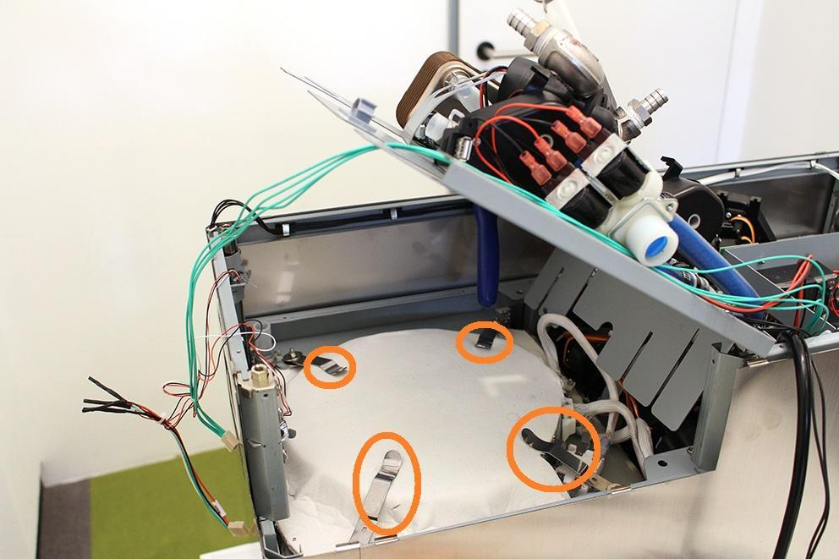

2. Be careful with cables while reassembling!  
 

3. Be careful not to crumble the silicone flange around the button while reassembling the button!

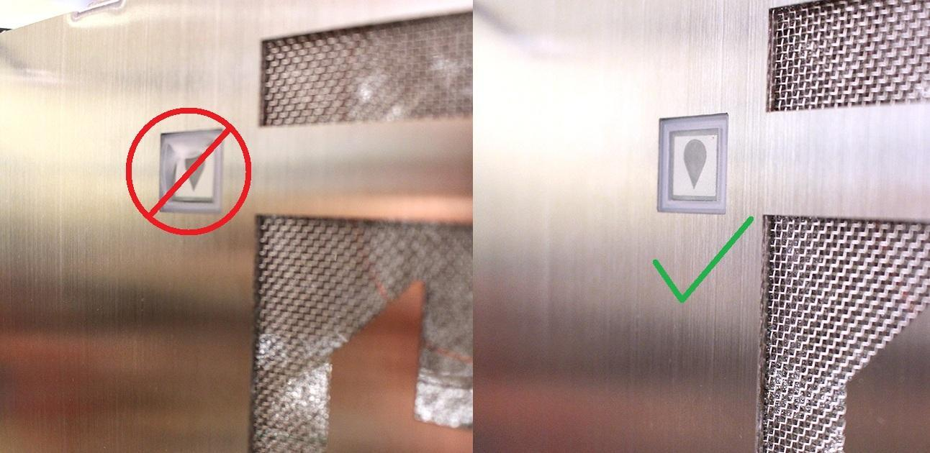

4. Make sure that the pumps are in the specified angle. Otherwise the pumps will not work properly. Use cable tie to fix the pump.

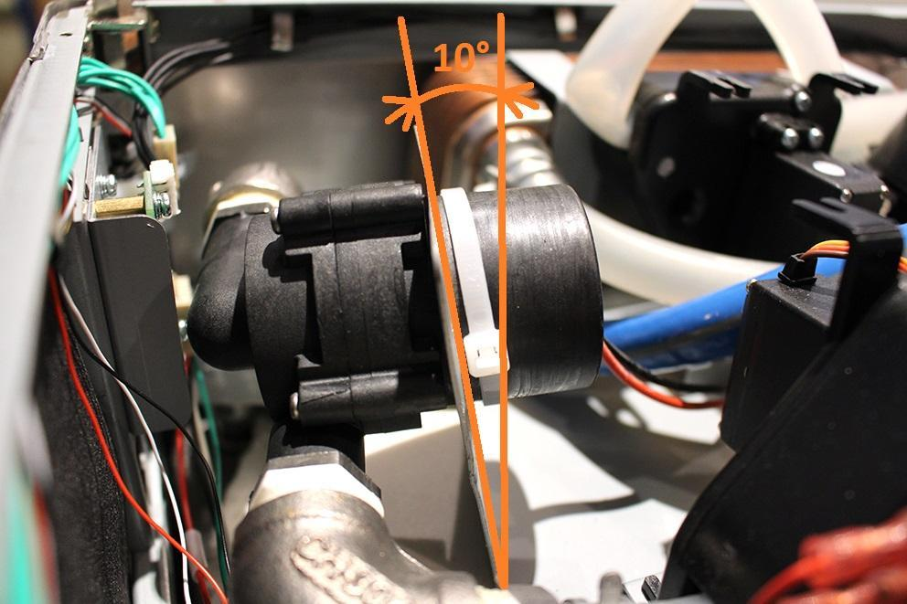

5. Place the heat insulation back to the original area.



6. Make sure that the wort outlet hose clamp is in the proper angle. Otherwise you cannot reassemble the bottom sheetmetal.

